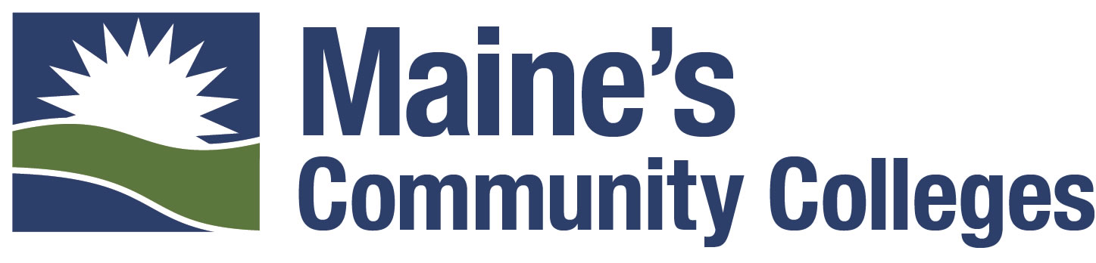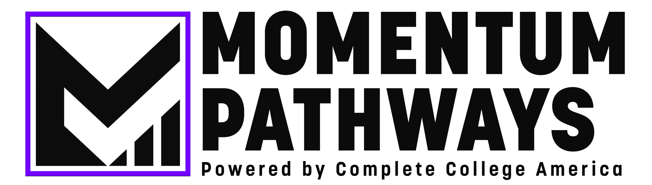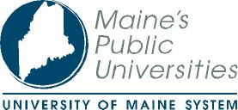

COMPLETE COLLEGE MAINE
Student Success Summit
19 June 2019
8:30 – 4:00

Eastern Maine Community College, Bangor

TIME | SESSION | LOCATION
8:30 - 9:00 | Registration and Networking | Maine Hall
9:00 - 9:15 | Welcome  David Daigler, President, MCCS  James Page, Ph.D., Chancellor, UMS | Maine Hall  Rooms 117-120
9:15 - 9:20 | Overview  Janet Sortor, Ph.D., Chief Academic Officer, MCCS  Rosa Redonnett, Chief Student Affairs Officer, UMS | Maine Hall  Rooms 117-120
9:20 - 10:45 | Momentum Pathways: A Sequenced Approach to Equitable Student Success  Monika Mala, Ph.D., Director of Alliance Relations  Since the launch of CCA in 2009, the organization believed that our institutions of higher education need to adapt to the changing demographics of students to ensure that more students complete a higher education credential of value. CCA’s Momentum Pathways is a specific guided pathways approach that places emphasis on creating and maintaining student momentum from the first year to completion. | Maine Hall  Rooms 117-120
10:45 - 11:00 | Break
11:00 - 11:50 | National – Best Practice Perspective  Momentum Year: Credit Accumulation, Gateway Course Completion, and Crucial First-Year Benchmarks  Vanessa Keadle, Senior Strategy Director, Complete College America  In this interactive session, participants will assess current levels of the Momentum Year strategy implementation at their institution, determine gaps and areas of focus, and learn more about evidence and national promising practices in placement, credit accumulation, co-requisite support, and other momentum-building strategies.  Proactive Advising: Using Purpose First & Academic Maps to Keep Students on Track  Monika Mala, Ph.D., Director of Alliance Relations, Complete College America  In this session, the presenter will share data and best practices around the onboarding process and the academic sequence of courses for students. This interactive session will provide practitioners with tools to assess institutional efforts and resources to implement strategies at scale.  A Better Deal for Returning Adults: A Layered Approach to Student Success Strategies  Nikolas Huot, Strategy Director, Complete College America  This session will focus on best institutional and national practices to support new and returning adult learners towards their goals of completing a college degree. Data, institutional examples, and resources will be presented to participants. | Maine Hall  Rooms 117-120  Maine Hall Student Success Center  Katahdin Hall  Library
NOON | Lunch - Table Reflection and Networking | The Quad
1:00 - 1:50 | Regional Activities  Think 30/ 15 to Finish  Jeffrey Hecker, Ph.D., Executive Vice President for Academic Affairs, University of Maine  The University of Maine launched its Think 30 initiative in 2015 to encourage students to complete 30 credits per year in order to more quickly complete their degrees while saving money and reducing debt. Dr. Hecker will explain what they have done, show data on impact and discuss challenges, unintended consequences and things they could have done differently.  Raising Math Completion Rates: Math Pathways  Darin McGaw, Chief Academic Officer, Washington County Community College  Elizabeth Russell, Chief Academic Officer, Eastern Maine Community College  Kathy Englehart, Chief Academic Officer, Kennebec Valley Community College  This session will present the work of the last two years by our colleges to develop math pathways more appropriately aligned to students' programs of study. A math pathway approach to a college degree means that the required courses will align with the industry needs of each program and that all students will be able to complete their gateway course in the first year of college. Students need to feel that the math they take is relevant, meaningful, and necessary for their future career – and this approach does that. Each pathway will be described, including an overview of learning outcomes, examples of the programs the pathways are intended to serve, and implementation strategies and schedules from now through the next academic year.  Guided Pathways  Philip Sisson, Provost/Vice President, Middlesex Community College Academic  Guided Pathways is a research-based approach that simplifies choices for students. Rather than a “cafeteria” model that allow students to choose from an abundance of disconnected courses, courses are grouped together to form clear paths through college and into careers, whether students enter those careers directly after graduation or transfer to a university for more study in their chosen fields. College students are more likely to complete a degree in a timely fashion if they choose a program and develop an academic plan early on, have a clear road map of the courses they need to take to complete a credential, and receive guidance and support to help them stay on plan. Middlesex Community College will share its experience building pathways that move students from high school through college to careers and baccalaureate programs.  Proactive Advising: Reality in Motion  Elizabeth Higgins, Ed.D., Director of Advising, University of Southern Maine  Come to this session and learn about how academic advisors use academic maps, learning outcomes, new/transfer student onboarding, communication plans, early alerts, and advising approaches to engage students in creating momentum to degree. Participants will have the opportunity to share their own ideas and experiences as well as identify possibilities for their own campuses.  Purpose First  Charles Ansell, Chief Operating Officer, Community College System of New Hampshire  The Community College System of New Hampshire (CCSNH) is one of four state teams participating in Complete College America’s “Purpose First” initiative, aimed at helping students make career exploration and planning an early priority in their academic journey. As part of this initiative, CCSNH is implementing an innovative course called “Ethnography of Work” that combines career research using Career Coach, visits to local employers, and a strong grounding in ethnography to equip students with the tools and information they need to make good career decisions. Early results have been positive, including a 33% higher retention rate for students enrolled in Ethnography of Work. Students in this class are also 50% more likely to narrow their academic focus by moving from undeclared status, or a broad meta-major like liberal arts, to a more precise major such as history or math. | Katahdin Hall  Library  Maine Hall  Room 222  Maine Hall  Room 226  Maine Hall  Student Success Center  Katahdin Hall  Room 316
1:50 - 2:00 | Break
2:00 - 2:30 | Reflections and Closing Remarks  Monika Mala, Ph.D., Director of Alliance Relations, Complete College America  Vanessa Keadle, Senior Strategy Director, Complete College America  Nikolas Huot, Strategy Director, Complete College America  Wrap up – “Here’s what we heard today and what we think the opportunities are” | Maine Hall  Rooms 117-120
2:30 - 2:35 | Transition  Leaders - (By Invite 0nly) – A session for Presidents, Chief Academic Officers, Chief Student Affairs Officers, Chief Enrollment Management Officers, Directors of Advising/Student Success, MCCS and UMS System Senior Staff  All Other Attendees – Ice Cream Sundae Bar Social | Maine Hall  Rooms 117-120  The Quad
2:35 - 4:00 | Leading with Momentum: Institutional Leadership Workshop  Vanessa Keadle, Senior Strategy Director, Complete College America  Leaders will engage in a robust discussion about the current state of higher education in Maine. By analyzing current initiatives, identifying opportunities for collaboration, and surfacing challenges, Maine leaders will move forward with a focus on collective impact for students in the state. | Maine Hall  Rooms 117-120

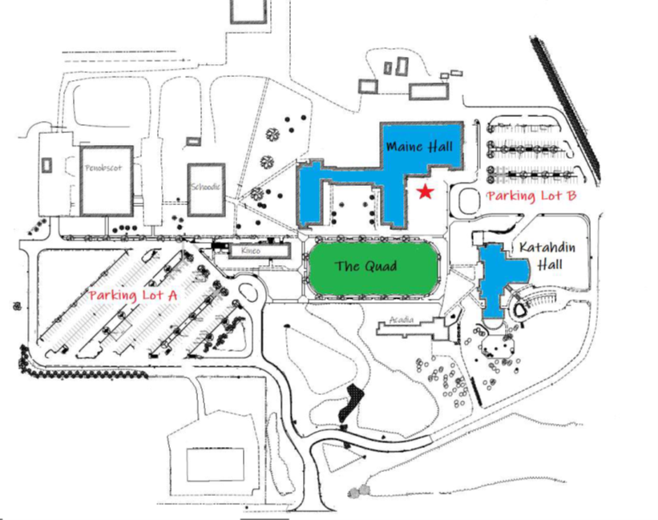
BIOGRAPHIES

CHARLES ANSELL is the Chief Financial Officer and head of Strategic Planning for the Community College System of New Hampshire, where he presently leads information technology, data and analytics, finance, and student success efforts for the state system, including its work in data, analytics, and compliance reporting. Prior to this, Charles was Senior Associate Vice Chancellor Strategy and Academic Governance at the City Colleges of Chicago, where he oversaw progress on student success outcomes, including specific measures pertaining to graduation rate, completion, and post-completion success. Charles has worked in strategy, information technology, and journalism. He holds a Master’s of Science in Business Information Technology from DePaul University and a Bachelor of Arts in Political Science from Carleton College.

DAVID DAIGLER was recently named President of the Maine Community College System having previously served as Chief Financial Officer from 2003-2019 and Vice President from 2015-2019. Overall, Daigler has nearly 20 years of service across the Maine Community College System and a total of more than 35 years of experience in financial management, operations, and administration. He is a long-time advocate for program specific innovations designed to transform academic programming to be more effective, accessible, and efficient in serving more Maine people. In 2018, he also served as Interim President of the Foundation for Maine’s Community Colleges. Prior to rejoining MCCS in 2003, he served as Vice President for Finance and Chief Financial Officer at Community Health Services in Portland and as Director of Administration at the Maine Medical Center Research Institute in Scarborough. And Daigler serves on the board of directors of the Finance Authority of Maine where he is treasurer and chair of the education committee. He has previously served on the boards of the Maine Technology Institute and North Yarmouth Academy. Daigler graduated from John Carroll University and holds a Master of Science in finance from Boston College. He and his wife reside in Portland and have two grown children.

KATHY ENGLEHART is the Academic Dean for the Kennebec Valley Community College System, a position she has held since 2017. Prior to that, she was a member of the science faculty at the college 32 years, serving in a variety of roles including adjunct faculty, full-time faculty, Chair of the Math/Science Department. Ms. Englehart received her Master’s degree in Microbiology from the University of Maine and is currently enrolled in an Ed.D. program with a specialization in Educational Leadership and Management.

JEFFREY HECKER received his Ph.D. in clinical psychology from UMaine in 1986 after earning the B.S. degree (Phi Beta Kappa) in Liberal Arts and Sciences (Psychology) from the University of Illinois. Dr. Hecker is a clinical researcher whose work focuses on understanding and treating anxiety, and more recently on risk assessment for people who have committed sexual offenses, including adolescents. In addition, he has extensive experience in providing research and clinical consultation to a variety of organizations including the Department of Corrections, Penquis Cap and Penobscot Job Corps. Dr. Hecker became the Executive Vice President for Academic Affairs and Provost in September 2013. He is primarily concerned with creating rich learning experiences for all UMaine students both in and out of the classroom. He is responsible for advancing UMaine’s research and public service missions as well and believes that the university’s tripartite mission is best accomplished when student learning, creation of new knowledge, and public service are fully integrated.

ELIZABETH HIGGINS has over 25 years of experience in academic advising. Throughout these years, Beth has implemented a dual advising program, developed advising assessment plans, coordinated professional development for advisors, led the University of Maine System-wide Advising Committee, and coordinated numerous retention and persistence initiatives. Most recently Beth has been the transition lead for academic advising at her institution. Beth has been active in NACADA at the regional and national levels. In addition to facilitating numerous conference presentations, she has served as a NACADA Board of Directors member, Chair of the Commission for Undecided and Exploratory Students, member of the Commission and Interest Group Steering Committee, and has been a contributor to the NACADA Clearinghouse, Academic Advising Today, and Advising Administration Monograph. Beth received her B.S. in Business Administration and her M.S. in Adult Education from the University of Southern Maine and earned her Ed.D. in Education with a Higher Education Administration concentration from Northeastern University. Her research focuses upon the faculty and student advising relationship.

NIKOLAS HUOT worked as the Associate Director for First-Year and Transition Programs with the Office of Student Success at Georgia State University, prior to joining Complete College America. In this role, he coordinated, assessed, and scaled all success and retention initiatives for incoming first-year students at the bachelor’s and associate’s degrees, including learning communities, structured schedules, summer bridge, peer mentors, first-year seminar, and first-generation students. In addition to his work in student success, Nikolas spent over five years as a college scheduler where he maintained the academic schedules and master curriculum of a number of departments. To this day, he remains closely involved with all aspects of student registration and course scheduling at the university level. At CCA, Nikolas works on planning and implementing 15 to Finish, Purpose First, MSI Initiative, Momentum Year, Academic Maps, Proactive Advising, and Seal of Approval in an effort to closing achievement gaps.

VANESSA KEADLE serves as the Senior Strategy Director for Co-requisite Support and Math Pathways. In this role, she supports Complete College America’s efforts to implement remediation and mathematics reform strategies in regions and states. She develops, implements, and evaluates project management practices that enable states, postsecondary systems and postsecondary institutions to scale reform strategies to dramatically increase completion rates. Prior to joining Complete College America, Vanessa spent nearly three years working for the West Virginia Higher Education Policy Commission as the Coordinator for Research and Evaluation in the Division of Student Affairs. In that role, Vanessa worked with West Virginia GEAR UP to evaluate the grant program by incorporating data collection strategies to enable rigorous research designs that supported the work of the college access program. Vanessa’s prior experience in higher education include serving as the Director of Student Life at Marshall University in West Virginia where she worked for almost five years to assist students, parents, and other university stakeholders in navigating key institutional policies to better support retention and success. Before Marshall University, Vanessa served as the Assistant to the Director of Student Affairs at Penn State, New Kensington campus where she planned student engagement activities, including new student orientation and leadership development workshops. Vanessa is currently working towards her education doctorate degree and is writing her dissertation which focuses on co-requisite support and college student persistence. She holds a master’s degree in higher education administration from West Virginia University and a bachelor’s degree in psychology from Bethany College.

MONIKA MALA is the Director of Alliance Relations for Complete College America. In this role, Monika serves as the main Complete College America lead to support Alliance state and consortia members in the West and Midwest. She works closely with each state to guide change, drive momentum and support completion initiatives, specifically through advocacy, policy, and coordination of implementation efforts. Monika most recently served as the Assistant Director of Access and Opportunities at the University of Nevada, Reno. In this role, she oversaw two federally funded programs, as well as one state funded retention initiative. She worked closely with the Nevada System of Higher Education, the Nevada Department of Education, and the U.S. Department of Education to successfully implement grant objectives statewide. Monika was responsible for leading advocacy efforts by meeting with lawmakers at the federal and state level, as well as public relation initiatives for access and retention work. Monika has a Bachelor of Arts in Journalism, a master’s in Counseling Educational Psychology and a PhD in Education with a focus in Equity and Diversity from the University of Nevada, Reno.

DARIN MCGAW is Dean for Academic Affairs at Washington County Community College. He holds a bachelor’s degree in Mathematics and a Master of Education in Student Development from the University of Maine, and a graduate certification in Mathematics from Converse College. He has 29 years’ experience in education with more than 26 of those years serving the Maine Community College System. Darin has held numerous positions at the College, including Assistant Dean of Students/Director of Admissions, Assistant Dean of Academic Affairs, Interim Academic Dean, Dean of Community Education, Dean of Student & Community Affairs, and Mathematics Instructor.

JAMES PAGE was appointed Chancellor by the University of Maine System Board of Trustees in March 2012 to lead their repositioning of the University System to meet Maine’s 21st century higher education needs. Prior to becoming Chancellor, Dr. Page was principal and CEO of the James W. Sewall Company, a national consulting organization founded in 1880 and headquartered in Old Town, Maine, specializing in forestry, natural resources, civil and spatial engineering. Page is the first University of Maine System Chancellor to be born in Maine or to have been educated at one of the System’s universities. He was born and raised in Caribou, and obtained his BA in History from the University of Maine at Ft. Kent. Subsequently he completed Master’s work in the philosophy of physics from St. Andrews University, Scotland, and obtained his Ph.D. in the philosophical foundations of mathematics from MIT. He taught at several universities before joining the private sector and has served on a number of Boards in the public, private, and NGO sectors. Chancellor Page lives in Old Town with his family and will be retiring at the end of this month.

ROSA REDONNETT is the Chief Student Affairs Officer (CSAO) for the University of Maine System. The CSAO is responsible for advising the Chancellor, Chancellor’s Staff and the Board of Trustees on all matters affecting student life on the campuses of the University of Maine System (UMS), and most specifically on those matters impacting the persistence, graduation and success of all students within the UMS. She is a member of the core team of MaineSpark, Maine’s statewide attainment initiative, and specifically the Adult Promise (adult degree and credential completion) component of that work, where she serves as Maine’s SHEEO lead. Most recently, Rosa has led the UMS Adult Degree Completion initiative including co-chairing the work of the Micro Credential Steering Committee. Prior to her appointment to this position, Rosa served as the Vice President for Enrollment Management at the University of Southern Maine (USM) from 1994-2008, the Executive Director for Extended Academic Programs at USM from 1989-1994 and the Director of Summer Session at USM from 1987-1989. She received her MBA from Northeastern University and her BA in International Business from Simmons College.

ELIZABETH RUSSELL has served in a variety of capacities at Eastern Maine Community College for over 25 years. She began her career at the College as a member of the Business Management faculty. In addition to her current position as Vice President of Academic Affairs, she has also served as the Director of Admissions, Assistant Academic Dean, Associate Dean of Enrollment Management, and Dean of Student Success. A member of the Achieving the Dream Steering Team, Liz is committed to student success as evidenced by her work in building the Student Success Center at EMCC and securing the College's first-ever TRiO grant. Liz earned a B.S. and MSB from Husson University in Bangor, Maine.

PHILIP SISSON is currently Provost and Vice President of Academic & Student Affairs at Middlesex Community College. Provost Sisson has more than 25 years of college administration service mostly within the New England community-college system. Previously, Provost Sisson served as Vice President of Academic and Student Affairs and Dean of the Division of Language and Literature, Mathematics, Natural Sciences and Life Fitness at Cape Cod Community College. At the Community College of Rhode Island, Provost Sisson held several positions including Dean of Arts and Sciences, Dean of Workforce Education, and Chief Academic Officer of the Liston Campus/Providence. Provost Sisson received both his B.A. and M.A. from Rhode Island College with doctoral work at the University of Connecticut and UMass/Boston.

JANET SORTOR has served as the CAO for the Maine Community College System since 2015. She served as the VP and CAO at Southern Maine Community College and in variety of leadership roles at Bunker Hill Community College. Since joining the System, she has worked to increase access and student success, ensuring that Maine has a workforce with the advanced education and training necessary to meet the needs of the 21st century economy. She holds a doctorate from the University of Massachusetts; a master’s degree from Boston University; and bachelor’s degree from Eastern Michigan University.

ARE YOU LOOKING FOR WIFI?

- Join ‘EMCC’ WiFi network
- A webpage should pop up. If one doesn’t, open a web browser.
- Enter ‘dirigo@emcc.edu’ for a username, ‘Summit2019!’ for the password on the authentication web page.

